**Article name:** Intelligent an Architecture Based on Field Programmable Gate Arrays Designed to Detect Moving Objects by Using Principal Component Analysis

**Task:** 06

**Prepared By:** Batch04

**Name:**

* Amrutha Varshini
* Harish
* Mallikarjuna
* Ajay Prakash
* Vishal Babu
* Radha Chaurasiya
* Venkata Sai Kumar

**Date of Submission:**

**Report on this Article:**

**Summary:**

* This paper is focusing on implementing the PCA algorithm in FPGA for getting high rate background segmentation of images.
* The proposal is providing information such as the image obtained has high ratio of processed images and hardware made up of CMOS and FPGA devices
* The classical sequential execution of different parts of the PCA algorithm has been parallelized. This parallelization has led to the specific development and implementation in hardware of the different stages of PCA, such as computation of the correlation matrix, matrix diagonalization using the Jacobi method and subspace projections of images.

**Algorithm of PCA:**

* Principal Component Analysis (PCA) is a method that is used in different fields, such as statistics, power electronics or artificial vision. The main feature of PCA is the reduction of redundant information, retaining only information that is fundamental (principal components)
* Obtaining the principal components of an image

**Description of the Architecture:**

* CMOS sensor controller: This block is responsible for implementing image demands to the CMOS sensor such as parameterizing its internal registers according to the desired configuration (images per second, exposure time, etc.).

• Image capture controller: the purpose of this block is to allow the user to select an area of interest within the image from the CMOS sensor.

• External memory controller: the system is equipped with a 128 MB, SDRAM memory bank that is external to the FPGA. Images from the CMOS sensor are stored in this bank.

• Communications Controller with the PC: this block controls the communication between the FPGA and the PC. This is used to transmit commands and results.

• Head Controller: This block is responsible for synchronizing the entire system so that everything works correctly and at maximum speed.

• PCA algorithm: This block implements the PCA algorithm and its implementation is the most important contribution of this work.

**Implementation PCA in FPGA:**

* Generating the eigenvectors
* Mathematical equations
* The on-line stage

**Results:**

* This section sets out the results obtained in detecting new objects with a FPGA running PCA algorithm. All the images presented in this work have been captured by an “intelligent camera”
* As a result of this, motion of the image is detected in each and every stage making it more accurate.

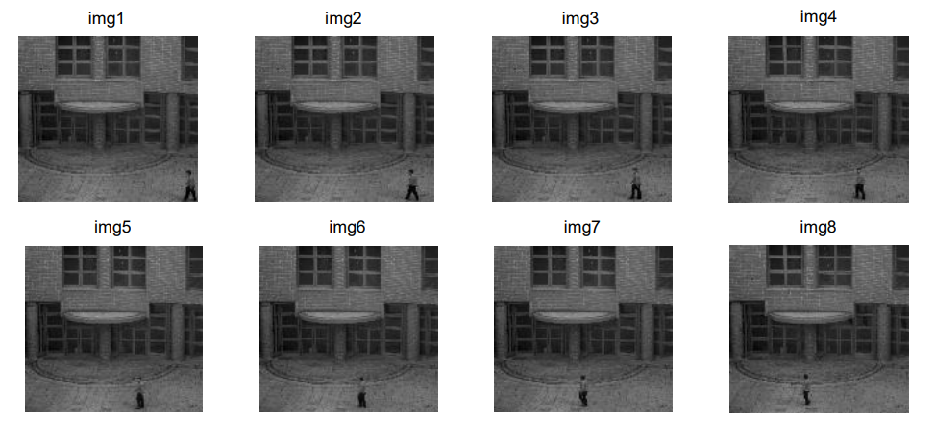

* From this image it is clearly visible how the images are captured with high resolution.
* This image shows the motion of the person and how he is in the frame. Thereby it concluded that by implementing PCA in FPGA helps in object detection.

